RAD-S102 series radiation detection probes

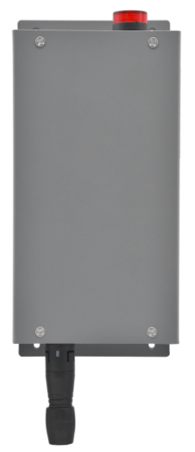
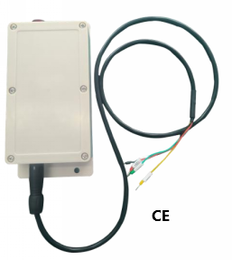

I. Overview:
RAD-S102 series fixed radiation probe adopts energy compensation type GM counter tube, which can detect γand X rays in the environment or products in real time and quickly. It can be used together with GM-R200 host or independently, and output in RS485 mode, which is convenient for system integration. All probes can be independently connected with alarm lights, and an audible and visual alarm can be given on the spot when the threshold is exceeded.
Second, the main features:
1. Efficient GM tube detector with high sensitivity and fast response.
2. It can be wall-mounted and can be externally connected with high-decibel audible and visual alarm.
3. The sensor can be equipped with wireless data transmission function.
4. Output RS485, which can be connected to PLC.
III. Technical indication parameters:
model  parameter | RAD-S102 | RAD-S102X(CE)
Measuring ray type | γ and X-rays | γ and χ rays
Measuring range | 0.01μSv/h～100mSv/h | 0.01μSv/h～50mSv/h
sensor | energy compensation sensor | Semiconductor sensor
Alarm function | Acousto-optic alarm | Acousto-optic alarm
Energy range | 40KeV～1.5Mev | 35KeV～3Mev
sensitivity | About 1600CPM/mR/h (for Cs-137) | About 20CPM/mR/h (for Cs-137)
Relative inherent error | γ：±20% X：±30% | γ：±15%X：±25%
Power Supply | 12-24V | 12-24V
correspondence | RS485 MODBUS communication protocol | RS485 MODBUS communication protocol
weight | About 270g | About 260g
Overall dimension (mm) | 187*90*45mm (including mounting piece) | 187*90*45mm (including mounting piece)
authentication | Radiation safety license, IS09001 | Radiation safety license, IS09001
quality assurance date | The whole machine is guaranteed for one year | The whole machine is guaranteed for one year

- Installation mode
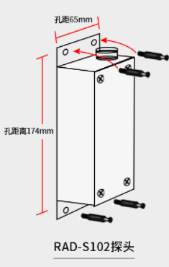
Screw installation

(1) Put the probe in the position where it needs to be installed, mark the four installation holes with a marker, punch holes on the wall with an impact drill, and knock the plastic swelling into the wall (as far as possible), then align the four holes on the detector installation plate with four screws and tighten them with screws;

V. Communication protocols
Wiring definition: red: +12VDC, black: power ground, green: 485-A, yellow: 485-b.
Communication interface parameters:Communication method: RS485
Protocol: MODBUS-RTU
Device address: 0x01
Baud rate: 9600bps
Data bits: 8
Stop bit: 1
Check Digit: None
The communication protocol:
Register address | Register content | type of data | R/W | Description
0001 | (μSv/h * 1000) | Integer long | R | Byte order ABCD
0003 | (mR/h * 1000) | Integer long | R | Byte order ABCD
0005 | (CPS * 1000) | Integer long | R | Byte order ABCD
0013 | Smooth averaging | Integer long | R | Read radiation with slow averaging
0021 | Device address | Integer long | R/W
0023 | Baud Rate | Integer long | R/W | 1=9600  2=19200
0029 | Alarm | Integer long | R/W | in (μSv/h * 1000)

Device address may be read by command 0x11. Module replies with It’s own address.
Get dose rate command: 01 03 00 01 00 02 95 CB
Module response: 01 03 04 FF 00 00 00 CA 27
01 indicates that the module address is 1, 03 reads the register function code, 04 has a data length of 4 bytes, and the last two bytes are CRC check codes. In this example, the dose rate data is FF 00 00 00.
Analytical method: FF+(00× 0x100)+(00× 0x10000)+(00× 0x1000000) = 255 NSV/h = 0.255 μ SV/h.
Module address 1 changed to 2,0106001500219cf.
The baud rate of the module is changed from 9600 to 19200,010600,170002b80f.
When the module address is unknown, get the module address fixing command: 00 11 C1 BC.
Module response: 02 11 04 02 00 00 00 00 CB F9, the first byte is the module address, that is, the module address is 02.
Acousto-optic alarm value setting command: for example, the module address is 1, the alarm value is set to 2.5μSv/h, 01 06 00 1D 09 C4 1E 0F, the module reply: 01 06 04 C4 09 00 00 17 54, 09 C4 is used when setting 2500, and the data byte order of the module reply is C4 09.
Precautions:
1. The module is preheated for 3-120 seconds, the preheating time is not fixed, and the value is invalid. In the preheating stage, the module returns to the value of 010304F6fffFf8B.
2. The module does not support reading more than two registers continuously.
3. In the process of using communication, there is a very low probability of communication failure. If 0x83 appears in the second byte of the data packet replied by the module, it means that the module failed to respond to the command, so we must make a judgment. We cannot simply judge the CRC check code to avoid parsing the wrong data.
4. The 13th register is a smooth mode of dose rate, which is different from the first register in that the data is stable and the response is slow, so it is suitable for low dose rate environment.

VI. Matters needing attention
To keep the instrument in good condition, please use and read the following carefully.
Do not touch the instrument with radioactive surfaces or materials, so as not to pollute the RAD-S102X radiation sensor.
Do not place the instrument at a high temperature above 50℃, and do not expose the instrument to the sun for a long time.
Don't wet the instrument, it will damage the circuit board and Geiger tube.
Don't put the instrument in the microwave oven, it can't detect microwaves, which may damage the instrument and the microwave oven.
This instrument may be sensitive to radio frequency, microwave, static electricity and even electromagnetic field, but it can't work normally.

VII. Warranty and after-sales service
Please discuss with the supplier where you buy the product for the related instructions of repair and use.
- Warranty validity period
Within 12 months from the date of purchase.
- When maintenance is needed
During the warranty period, the damage caused by man-made damage, natural disasters and improper use is not covered by the warranty.
If it is out of the warranty period, it needs to be sent back to our company for inspection and quotation before it can be repaired and sent back.
- The right to interpret this manual belongs to Shenzhen Wanyi Technology Co., Ltd., official website.http:www.onetestinc.com
Company headquarters address: Unit 601, Building B, Huaqiang Creative Industry Park, Guanguang Road, Guangming Street, Guangming New District, Shenzhen.
Hotline: 400-0755-383 Tel: 0755-29058210/11/12.

